Project Initialization and Planning Phase

Date | 18 September 2026
Team ID | MCA
Project Name | Smart phone usage & digital addiction well-being analytics
Maximum Marks | 3 marks

Define Problem Statements (Customer Problem Statement Template):
Create a problem statement to understand your customer's point of view. The Customer A student who uses a smartphone regularly
Problem Statement template helps you focus on what matters to create experiences people will love. A well-articulated customer problem statement allows you and your team to find the ideal solution for your customers' challenges. Throughout the process, you’ll also be able to empathize with your customers, which helps you better understand how they perceive your product or service.
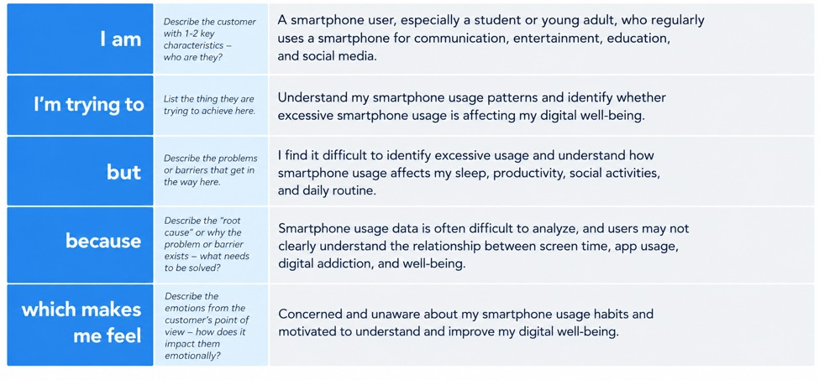

Problem  Statement (PS) | I am  (Customer) | I’m trying to | But | Because | Which makes me feel
PS-1 | A student who uses a smartphone regularly | Understand my smartphone usage patterns and maintain a healthy digital lifestyle | Excessive smartphone usage affects my studies, sleep, and daily activities | I spend too much time on social media, entertainment, and other applications | Distracted, less productive, and concerned about my well-being
PS-2 | A student who wants to improve digital well-being | Track screen time, application usage, sleep patterns, and productivity | I do not have a clear analytical view of my digital habits | Usage data is difficult to organize, compare, and understand | Worried about digital addiction and difficulty managing smartphone usage

